Wonders of China
You are traveling with ‘wendywutour’. They suggest that you travel with at least ten people.
Vaccinations
They recommend that you should contact your GP
Temperature
this is what they suggest about the temperature during a Chinese summer
Please note: These are  Averages only! | June |  | July |  | August
 | Temp  ˚C  min/max | Humidity | Temp  ˚C  min/max | Humidity | Temp  ˚C  min/max | Humidity
BEIJING | 18 / 31 | HIGH | 21 / 31 | HIGH | 20 / 30 | HIGH
CHENGDU | 20 / 29 | HIGH | 22 / 31 | HIGH | 21 / 30 | HIGH
CHONGQING | 22 / 29 | HIGH | 24 / 34 | HIGH | 25 / 36 | HIGH
GUILIN | 23 / 32 | HIGH | 25 / 33 | HIGH | 24 / 33 | HIGH
SHANGHAI | 19 / 28 | HIGH | 23 / 34 | HIGH | 23 / 32 | HIGH
KUNMING | 16 / 25 | HIGH | 16 / 25 | HIGH | 15 / 25 | HIGH
LIJIANG | 16 / 25 | MED | 17 / 26 | HIGH | 17 / 28 | HIGH
TAIYUAN | 14 / 29 | MED | 17 / 32 | MED | 16 / 30 | HIGH
XIAN | 18 / 33 | MED | 21 / 33 | HIGH | 20 / 33 | HIGH
ZHONGDIAN | 15 / 22 | MED | 15 / 22 | MED | 14 / 22 | MED

It is good to back a day pack
Trip Highlights
• Beijing – The Great Wall, Forbidden City & Tiananmen Square
• Xian – The archaeological marvel of the Terracotta Warriors
• Yangtze River Cruise – Spectacular Scenery of the Three Gorges
• Guilin – Beautiful landscapes of the Li River & nearby Yangshuo
• Shanghai – Exploration of China’s most cosmopolitan city

Meals
All meals (excluding drinks) are included in their fully inclusive group tours from the groups’ arrival until the day of departure. Their schedule of meals is designed so that you can experience the local dishes, their individual flavours as well as the different ways they are prepared and cooked throughout China.
Cost
Tour cost $4,090,
Airline Fuel Surcharge $511 & tipping $88 (Subject to change with Tipping payable on arrival in China.)

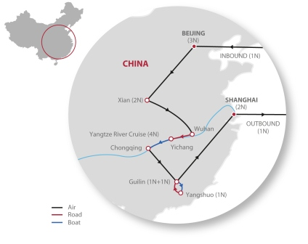
Day 1&2: Australia/Beijing
Depart from Australia for your overnight flight to Beijing. Your flight arrives early in the morning and you will be met at Beijing airport in the arrivals hall by your Local Guide and/or National Escort from Wendy Wu Tours. Together with all other group members who may be arriving at a similar time, you will transfer (1 hour drive) to your hotel. A tour introduction will be held in the hotel either this evening or the next. There will not be food or drinks served at this meeting; it is simply an opportunity for your group to meet and learn more about travelling in China.
Day 3: Beijing
Sightseeing in central Beijing involves 3 to 4 hours on foot during the morning to see Tiananmen Square and the Forbidden City. Afterwards you visit the Temple of Heaven, which involves approximately 2 hours on foot.
Day 4: Beijing
There is an early rise this morning to drive 2 hours (60km) northwest of the city to the Juyongguan Pass section of the Great Wall. The aim of this is to avoid the crowds of tourists who will arrive later in the morning, and the heat of the day. Visiting the Wall involves walking from the bus to the first section. After your group has been given an introduction to the Great Wall’s unique history you will have free time to explore the rest at your own pace. Then drive 1 hour to the Summer Palace in the north of the city where exploration involves approximately 1.5 to 2 hours on foot.
Day 5: Beijing/Xian
Transfer (1 hours’ drive) to the airport to catch a flight to Xian flight duration 1 hour, 50 minutes). As we will arrive before rooms are likely to be available, we will visit the Shaanxi Provincial Museum before checking into the hotel.
Day 6: Xian
The Museum of the Terracotta Warriors is located more than 1 hours’ drive outside of Xian. From the bus park to the Museum entrance is a 15 minute walk. There are electric carts offered by private vendors which can be organised at your own cost. There is no electric cart available for the return from Museum exit to Bus Park. Within the Museum area the warriors can be seen in 3 different “pits”, which are active archaeological digs. The site is large and, towards the summer months, can be hot outside. Sightseeing here involves 2.5 hours on foot. This afternoon we visit the City Walls. The Local Guide will give you time to explore at your own pace. There are options here to hire a bicycle or an electric cart to drive along the length of the walls. These are offered by private vendors and can be organised at your own cost. Beware of your valuables while in the Muslim Quarter’s alley market stalls.
Day 7: Xian/Wuhan
The morning flight to Wuhan is 1 hour, 15 minutes in duration. Then transfer (4 to 5 hours’ drive) from Wuhan airport to the docks, located downstream from the Three Gorges Dam. Board the ship and check-in to your cabin for the next 4 nights.
Day 8: Yangtze River Cruise
Shore excursion to the site of the Three Gorges Dam (4 hours off ship): Disembark ship and drive (approximately 20 minutes) to the Three Gorges Dam. Coach will drive through the construction areas (they are NOT allowed to stop for photos) and drop you off at viewing area above the locks. There is a small museum and lookout. Cruise through the Xiling Gorge. 2nd night on board with Captain’s Welcome Dinner.
Day 9: Yangtze River Cruise
Cruise through the Wu Gorge. Today, you will visit either the Lesser Three Gorges OR Shennong Stream. Shore excursion at Lesser Three Gorges (2 to 3 hours off ship): Transfer between the ship and small ferry at Wushan, then travel up the Daning River to see the remains of an ancient plank walkway and suspended coffin and enjoy the undisturbed natural scenery. Shore excursion at the Shennong Stream (3 hours off ship): Transfer between the ship and small ferry, to travel further up the Shennong tributary approximately 20 minutes. Then transfer from the ferry onto the small peapod rowboats, to experience the tradition of the ‘boatmen’ or ‘trackers’. 3rd night on board.
Day 10: Yangtze River Cruise
Cruise through the Qutang Gorge. Today, you will visit either Shibaozhai Temple on the south bank, OR Fengdu on the north bank. Shore excursion to Shibaozhai Temple (2 hours off ship): This small temple was built at the top of a 9 storey pavilion clinging to the sheer south bank near Qutang Gorge. Disembark from the ship to the dock close to the pavilion’s entrance. Sightseeing here involves climbing the 9 storeys inside the building. Shore excursion to Fengdu “Ghost City” (2 hours off ship): The town of Fengdu was relocated across to the south bank for the Three Gorges Dam Project. The Fengdu “Ghost City” Temple lies on the steep hill above the demolished town. Disembark via a pontoon and walkway. There is a free passenger ‘cart’ which takes you up to the middle area of the temple complex. It can carry 10-12 people up at a time and takes about 3-5 minutes each way. You will then need to walk the rest of the way up. There are about 150-200 large steps, without handrails. 4th night on board with Captain’s Farewell Dinner.
[N.B: The passenger ‘cart’ is a temporary measure until the construction of an elevator from the port to Fengdu is complete.] Day 11: Chongqing/Guilin Check-out of cabins/ship early this morning and disembark from ship in Chongqing. Visit Chongqing Zoo’s new Panda House. Then transfer directly to the airport to catch an early evening flight to Guilin (flight duration 1 hour). Check-in for an overnight stay.
Day 11: Chongqing/Guilin
Check-out of cabins/ship early this morning and disembark from ship in Chongqing. Visit Chongqing Zoo’s new Panda House. Then transfer directly to the airport to catch an early evening flight to Guilin (flight duration 1 hour). Check-in for an overnight stay.

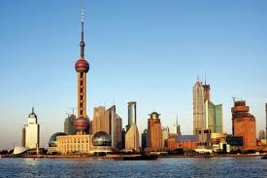
Day 12: Li River Cruise/Yangshuo.
[NB: You will be staying in Yangshuo for a single night before returning to Guilin. We recommend you leave your main luggage in safe storage at our hotel in Guilin; taking only a small, overnight style bag with you for Days 12 and 13.]
You will take a 3 hour cruise from Guilin to the small town of Yangshuo. A simple meal will be served on-board (usually before midday at “Chinese lunch time”).These are small cruise boats, usually holding approximately 100 passengers; with an enclosed dining area on lower deck and an open viewing area on upper deck. As it is so popular, there are generally many boats at the docks – please be reassured that the cruise itself will be scenic and relaxing as the boats cruise past unspoilt countryside. Usually the boats depart at 9am, from a dock 1 hours’ drive from your hotel. However when the river level is low they depart from further downstream which would mean a longer drive and an earlier check-out from your hotel. Disembarking from the cruise, your Local Guide will walk with you to your hotel, approximately 15 minute walk from the river. There are electric carts offered by private vendors which can be organised at your own cost.
Day 13: Yangshuo/Guilin
The drive back to Guilin takes 1 hour (65km). At the Reed Flute Caves you will take a short walk through the caves. It usually takes about an hour to complete the route, and it is very cool inside.
Day 14: Guilin/Shanghai
Transfer to the airport for your flight to Shanghai (flight duration 2 hours). Easy sightseeing this afternoon involves 2 hours on foot.
Day 15: Shanghai
Full day of sightseeing around the central city it will be 3 to 4 hours on foot. Beware of your valuables while in the Old Town (Yuan Bazaar) as it is very crowded.
Day 16: Depart Shanghai
Any time before your flight is at leisure. You will be transferred from the hotel to the airport, according to the departure time of your international flight.
Day 17: Australia
Arrive home.
Bibliography
Wendy Wu Tours [online]. (2012). http://www.wendywutours.com.au/wonders-of-china [Accessed 6.6.12]

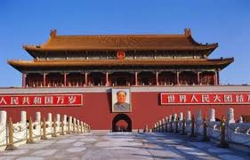
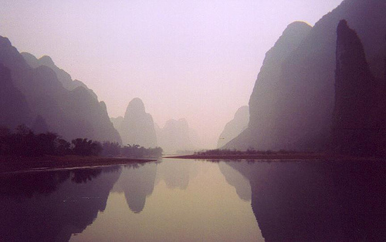
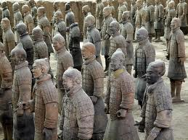
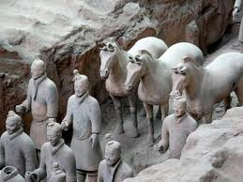
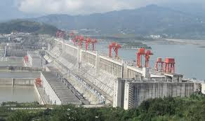
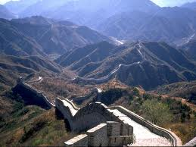
Gallery

