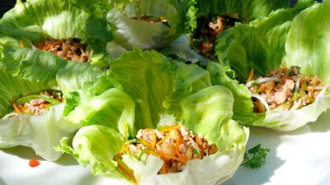
Saint Choy Bou Recipe
Ingredients:
3 Tablespoons peanut oil
3 shallots, finely chopped
3 table spoons of ginger minced
3tsp garlic minced
1tsp red chilli finely chopped
250g pork, minced
250g chicken thighs, minced
100g drained water chestnuts, chopped
6 squirts fish sauce
1 Tablespoon soy
¼ cup lime juice (2 limes)
2 teaspoons palm sugar
50gms Snow peas, julienned
50gms carrots, julienned
½ cup mint leaves
1 cup coriander
10 basil leaves
1 cup bean shoots
8 fresh crisp ice - berg leaves (whole if possible)

Method:
1. Heat peanut oil in a wok until it begins to shimmer slightly, add shallots, ginger, garlic and chilli and sauté until ingredients become translucent.
2. Add minces and sauté for a few minutes until just cooked through.
3. Add water chestnuts, fish sauce, soy, lime juice and palm sugar and cook fo a further 2 mins, until meat is cooked and has absorbed the flavours. Taste for sweet, sour and salt!
4. Add snow peas and carrots and cook for a further minute.
5. Remove from heat and add herbs and bean shoots.
6. Serve on a platter and allow guests to fill with spiced mince mixture.
7. Use toasted sesame seeds to sprinkle over at the end

Chinese Food Websites:
Chinese Food Recipe (San Choy Bou)
http://www.lifestylefood.com.au
Chinese Food
Chopsticks

