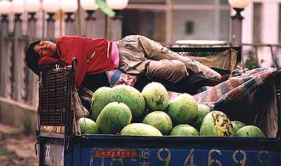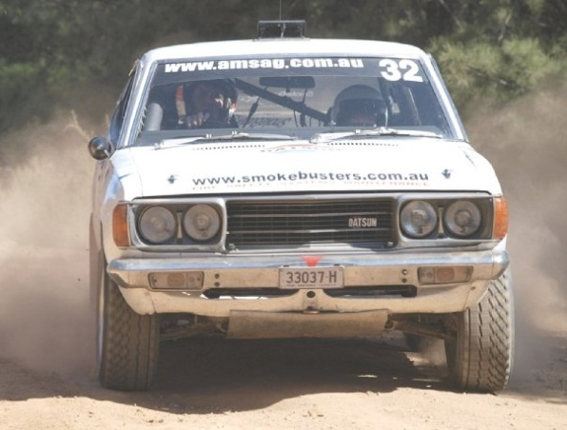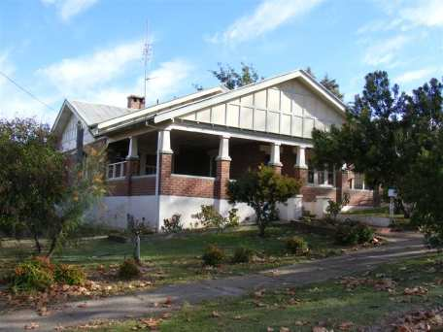[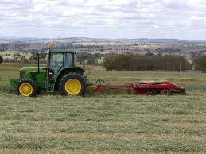](http://www.google.com.au/imgres?q=Cowra+nsw&um=1&hl=en&safe=active&biw=1366&bih=648&tbm=isch&tbnid=uCTexyfABMBE4M:&imgrefurl=http://www.flickr.com/photos/landlearnnsw/3702982756/&docid=N7rSoYWjihnroM&imgurl=http://farm3.staticflickr.com/2605/3702982756_b58d2b37ef_z.jpg?zz=1&w=640&h=480&ei=JDO0T9f9LYG4iQfE8LT_Ag&zoom=1&iact=hc&vpx=559&vpy=340&dur=1921&hovh=194&hovw=259&tx=193&ty=167&sig=101879300613315836467&page=3&tbnh=159&tbnw=250&start=42&ndsp=24&ved=1t:429,r:14,s:42,i:194)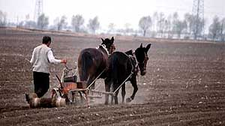

Transport is very dirty and it looks really old.

[Type a quote from the document or the summary of an interesting point. You can position the text box anywhere in the document. Use the Drawing Tools tab to change the formatting of the pull quote text box.]

Transport is nice and can go on most terrains.

[Type a quote from the document or the summary of an interesting point. You can position the text box anywhere in the document. Use the Drawing Tools tab to change the formatting of the pull quote text box.]

[Type a quote from the document or the summary of an interesting point. You can position the text box anywhere in the document. Use the Drawing Tools tab to change the formatting of the pull quote text box.]

Accommodation in Cowra is really pleasant and clean.

Accommodation in Heilongjiang is very poor and messy.

[Type a quote from the document or the summary of an interesting point. You can position the text box anywhere in the document. Use the Drawing Tools tab to change the formatting of the pull quote text box.]

[Type a quote from the document or the summary of an interesting point. You can position the text box anywhere in the document. Use the Drawing Tools tab to change the formatting of the pull quote text box.]

[Type a quote from the document or the summary of an interesting point. You can position the text box anywhere in the document. Use the Drawing Tools tab to change the formatting of the pull quote text box.]

[Type a quote from the document or the summary of an interesting point. You can position the text box anywhere in the document. Use the Drawing Tools tab to change the formatting of the pull quote text box.]

Ploughing winter wheat for hay, is a breeze with this machine.

Ploughing is always done with horses like in the olden days. They only other way to do farm work is by using mini tractors

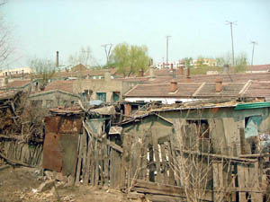

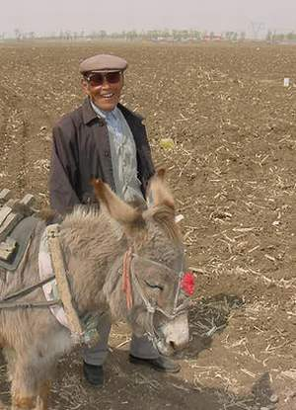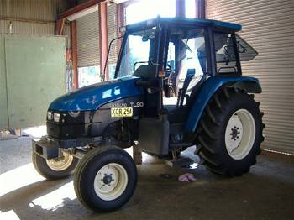

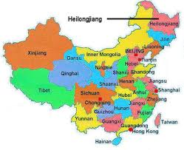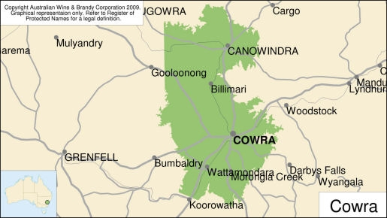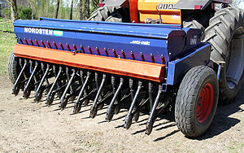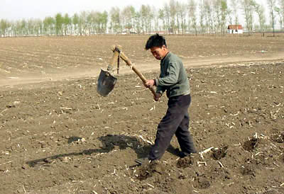

The two areas

Getting to work is slightly harder with a donkey?.....

Planting seeds is a lot harder with a shovel over acres of land.

Planting seeds is really easy with this machine.

Getting to work is easy with a good tractor in Cowra