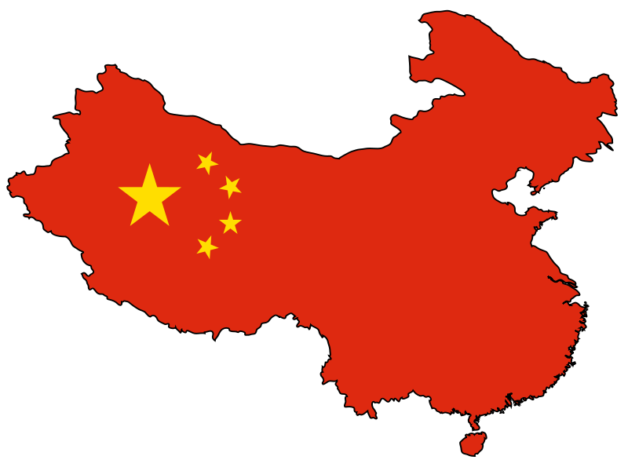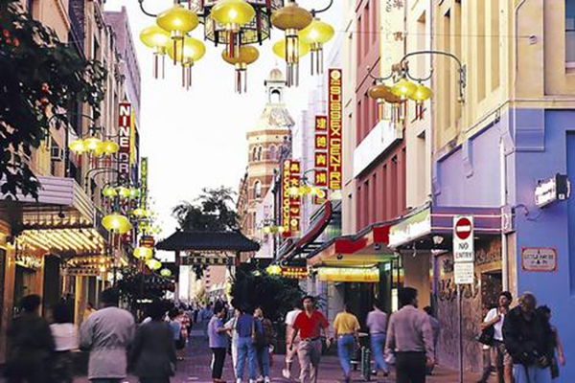

My Journey in China

By Caitlin Williams 6G

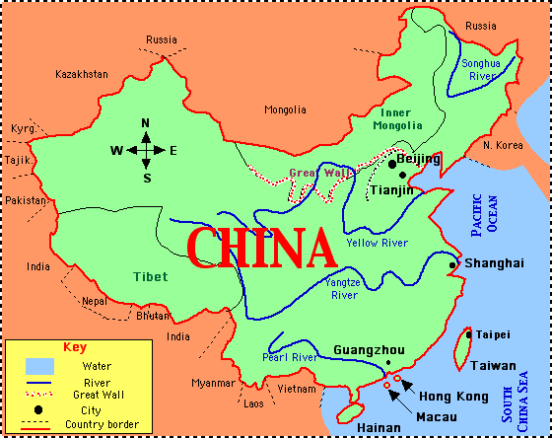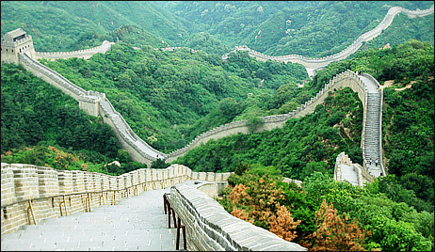

**Itinerary**



**Map**

**Australia to China (total distance: 11,937 miles)**

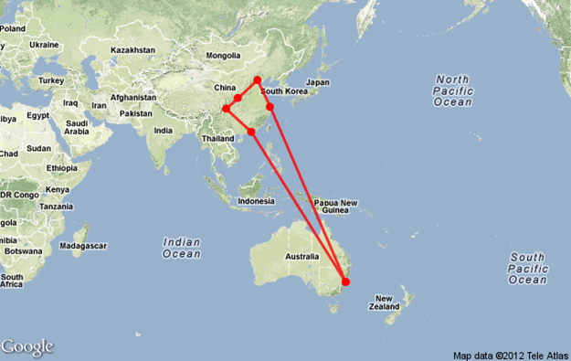

1. Sydney NSW, Australia
2. Shanghai, China
3. Beijing, China
4. Xi'an, Shaanxi, China
5. Chengdu, Sichuan, China
6. Hong Kong
7. Sydney NSW, Australia

**Within China (total distance: 2,450 miles)**

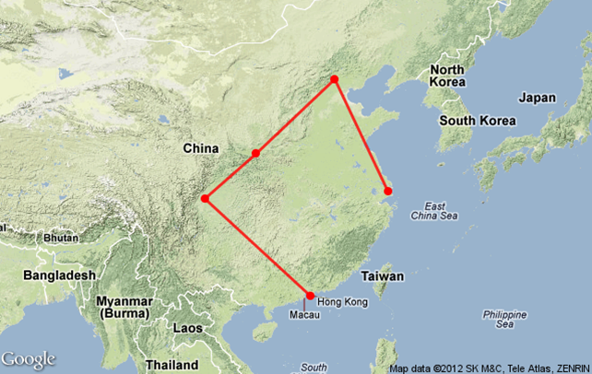

1. Shanghai, China
2. Beijing, China
3. Xi'an, Shaanxi, China
4. Chengdu, Sichuan, China
5. Hong Kong

**Before I Go**

**Passport/ Valid Visa**

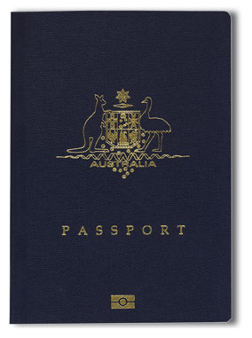To go to China you must have a passport that is still valid for six months after you arrive home from China. This is for all tourists going to China and this is stated by the Chinese Government. In your passport you will need one entire blank page to go to China.

To go to China you also require a visa unless you are a citizen of Japan, Singapore or Brunei. This visa covers the whole of China except for Tibet and a few other small areas in China. To get a visa for this trip you only need a standard 30-day visa. That visa will cost around US$30 for a citizen from another nation or US$50 for a US citizen. If you’re going into china more than once in a six month period you need a different type of visa. This visa can be issued from most Chinese Embassies and will take around three to five days to get to you in the five working days. The visa activates on the day you enter China and you must enter China in the three months beginning from when the visa is issued to you.

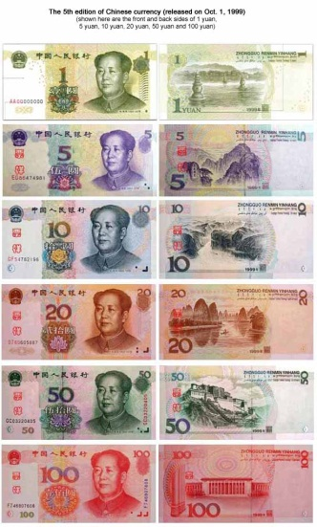**Money/Chinese Currency**

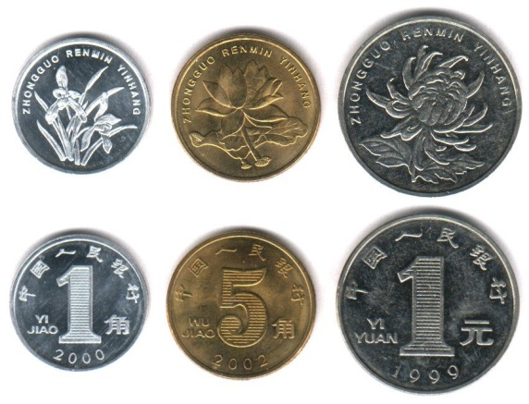The Chinese currency is Renmimbi (this means people’s currency) or Yuan. The main components of Renmimbi today are the Yuan and the Jiao. Yuan is practically like 1 Australian Dollar and a Jiao is basically like 10 cents which is a tenth of a Yuan. Renmimbi notes include the 100, the 50, the 20, the 10, the 5 and the 2 Yuan note. The Renmimbi coins include the 5 and the 1 Jiao coin. There is also a 2 Jiao note that is not a coin.

The exchange rate today is A$1=Yuan 6.2

In major cities you can use credit cards but in country towns it is best to have Renminbi (cash) as country towns are more basic.

In China you do not have to tip except for the top end restaurants (still no tips) when you get a big service charge.

**Vaccinations/Tablets**

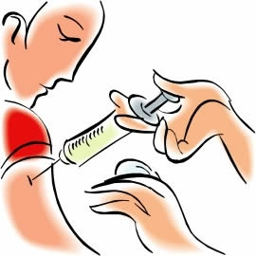When you are going to China it is not compulsory that you have vaccinations but for anyone’s safety to keep healthy I suggest you do. Here are the vaccinations that I suggest you have for this trip: The general routine vaccinations which are measles, mumps, rubella, pertussis, tetanus and polio/Hepatitis A /Hepatitis B and Typhoid. There are other vaccinations (such as Rabies and Japanese Encephalitis that are needed for rural areas only) that you could have but they are not needed for this trip.

**Travel Insurance**

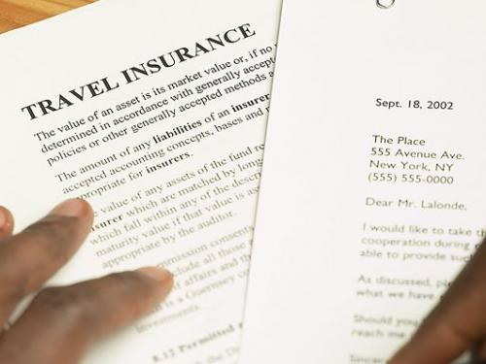For this trip in China for a family for travel insurance it will cost around about $150 dollars. This travel insurance will include: Overseas Emergency Medical Cover, Medical Expenses, Extra Expenses, Accidental Death, Permanent Disability, Loss of Income, Important Documents (Credit Cards, Passport), Stolen Cash, Loss of luggage(delay of luggage as well) and Personal Effects, Travel Delay, Transport Expenses, Personal Liability and Rental Vehicle.

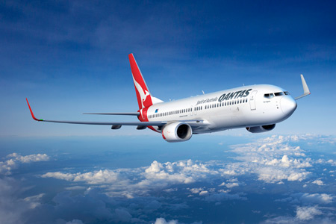**Flights**

For International Flights (flights between Asia and Australia) I will fly with Qantas in Economy. For domestic flights in China we will fly with local Chinese airlines – China Eastern and Dragonair. We will fly Economy class.

|  |  |  |  |  |  |  |
| --- | --- | --- | --- | --- | --- | --- |
| **From** | **To** | **Airport Code To/From** | **Airline** | **Flight Number** | **Class** | **Cost per person** |
| Sydney | Shanghai | SYD/PVG | Qantas | QF129 | Economy | $929 |
| Shanghai | Beijing | PVG/PEK | Qantas | QF4011 | Economy | $174 |
| Beijing | Xi’an | PEK/XIY | China Eastern | MU2106 | Economy | $162 |
| Xi’an | Chengdu | XIY/CTU | China Eastern | MU3117 | Economy | $97 |
| Chengdu | Hong Kong | CTU/HKG | Dragon Air | KA281 | Economy | $473.50 |
| Hong Kong | Sydney | HKG/SYD | Qantas | QF128 | Economy | $929 |

The total cost for three people is **$8293.50** and the total cost for one person is **$2764.50.**

More details of all flights are in the itinerary.

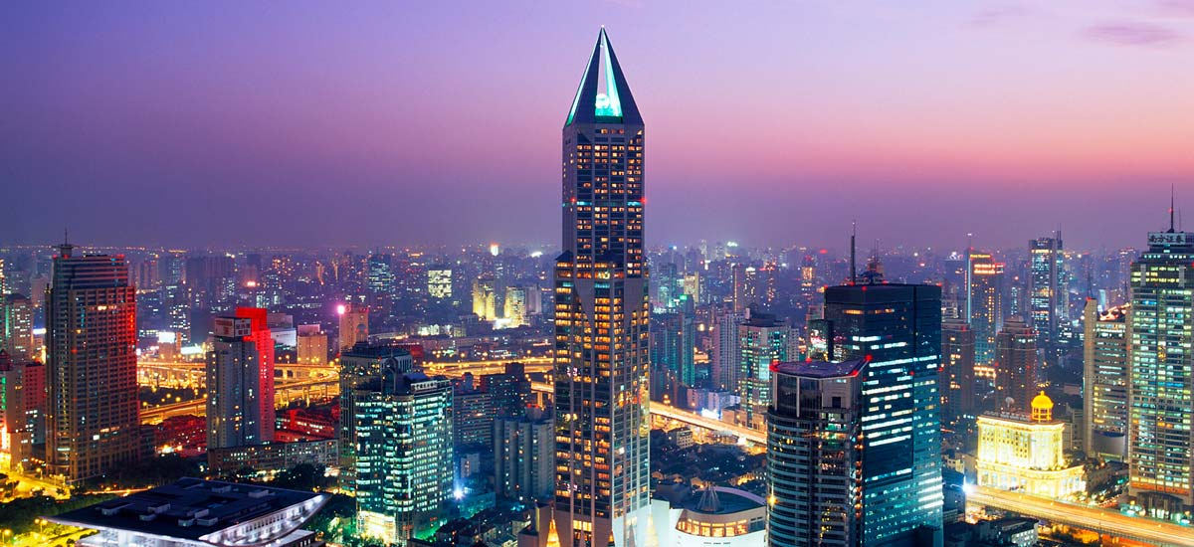**Destinations**

[**Shanghai**](http://en.wikipedia.org/wiki/Shanghai)

[**Weather**](http://www.tour-beijing.com/shanghai_tours/shanghai_climate.php)

|  |  |  |
| --- | --- | --- |
| **Month** | **High** | **Low** |
| June | 27-29 | 19-21 |
| July | 31-33 | 23-25 |

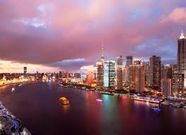**Accommodation**

Shanghai is famous for some of the top upmarket hotels. Yet on this trip we do not want to spend a fortune so there are some three star and four star hotels that would suit anyone just fine. A four star hotel that I found called Indigo is a lovely hotel that has good food and is straight on the bund and looking out on to the Yangtze River. If you want to stay in a really upmarket hotel that charges around 2,400 dollars a night the Four Seasons is the one to go to.

**Activities**

**The Bund and Shopping**

The Bund is the main street in Shanghai filled with shops, restaurants and practically everything you could think of. This day is for wondering round this part of Shanghai and doing some SHOPPING!

You will be walking.

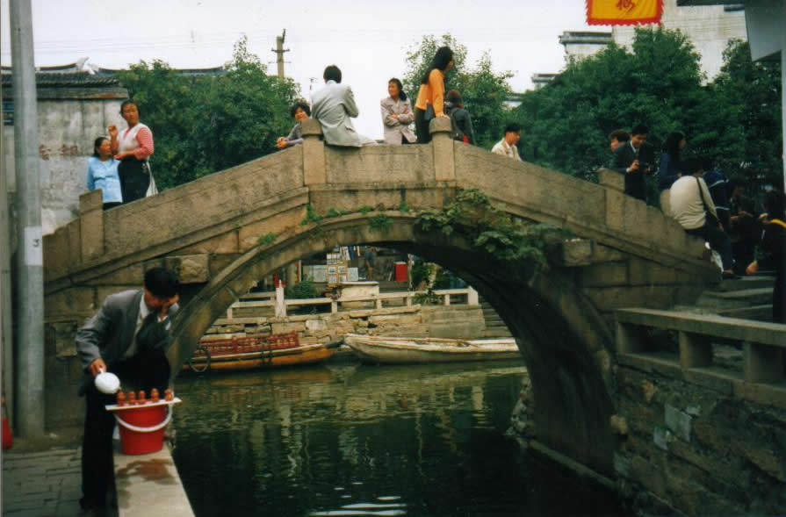**Canal Towns**

The Canal Towns are called China’s Venice. They are around about an hour away from Shanghai. They are little towns connected by canals. These canal towns are the more traditional ways of life not so much upmarket things. They have no green land what so ever and not even bikes are allowed in the towns you can only use small boats. They are a lovely way to see the area around Shanghai. You will have a private tour.

**Old City**

The old City is the original Shanghai that consists of small alleys, small doors and everything it used to be. This day will be about winding through back alleys and wandering round the old city and finding about something new while experiencing local culture

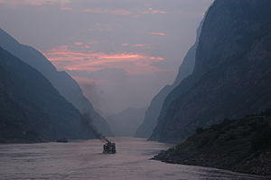**Yangtze River**

The Yangtze River is the main river that flows off the sea through Shanghai all the way inland to Nanjing. This river is used for everything: recreation, shipping and much more. You’ll be able to see from your hotel so it’s not very far away.

This day is also for relaxing from a few full days of sightseeing.

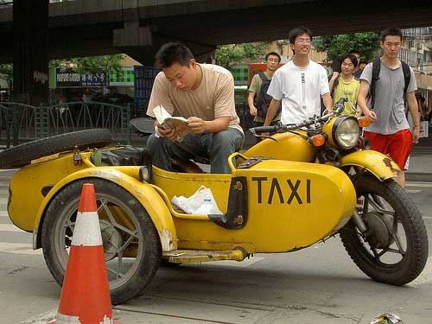**Getting Around**

Transport to and from the airport will be that first off you will take the Maglev (Magnetic Levitation Train that can go 400km an hour) and from the nearest station there will be a taxi to go to the hotel.

For all of the activities it will be a mixture of walking, using the subway and getting a taxi.

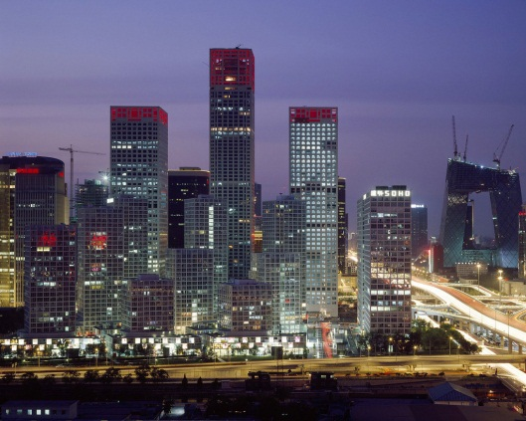[**Beijing**](http://en.wikipedia.org/wiki/Beijing)

[**Weather**](http://www.chinahighlights.com/beijing/weather.htm)

|  |  |  |
| --- | --- | --- |
| **Month** | **High** | **Low** |
| June | 27 | 20 |
| July | 31 | 24 |

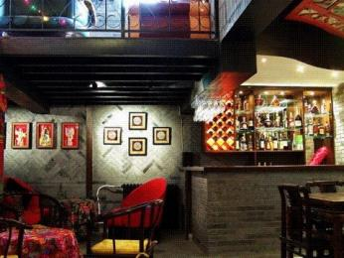[**Accommodation**](http://www.tripadvisor.com.au/Hotel_Review-g294212-d813642-Reviews-Double_Happiness_Courtyard_Hotel-Beijing.html)

In Beijing I would suggest you stay at a hotel I found called the Double Happiness Courtyard Hotel. Even though it is a three star hotel from what I have seen in the pictures it looks like a real slice of Beijing with all the decoration and rooms looking like it would be in a typical Beijing house. It is only 20 minutes’ walk to the Forbidden City and Tian An Men Square. If you would like to stay at a hotel with a pool the Hilton Wangfujing is a good hotel.

**Activities**

**Forbidden City and Tiananmen Square**

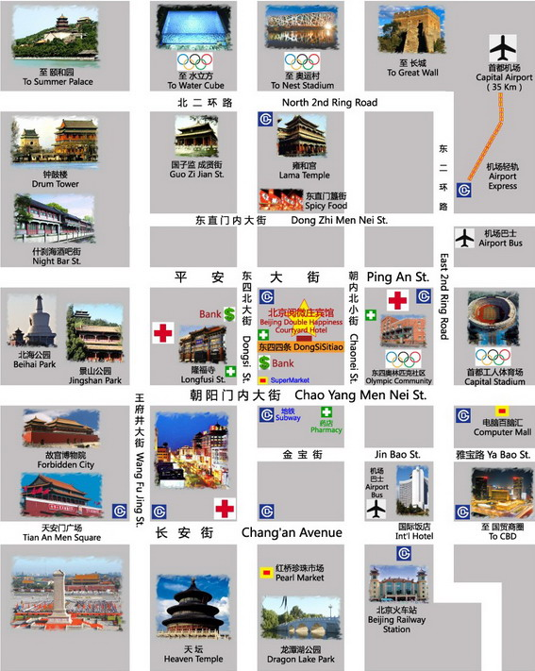The Forbidden City is the original Beijing that was home of many emperors from 1420 – 1923. It had up to 100,000 people living there so it is massive since it was the beginning of Beijing it is a piece of Beijing’s history. You can’t go to Beijing without going there.

Tiananmen Square is right beside the Forbidden City. It is a massive square (880m – 500m) that has the Forbidden City on one side and Mao’s Grave on the other side. Tiananmen Square is named after the Tiananmen gate (the gate of heavenly peace). The monument in the middle is a tribute to all the people who died whilst fighting for Chinese people and who did this in 19th and 20th century. It is called Monument to the People’s Hero’s. It is an amazing square that you can’t miss.

You will be walking around this day.

**Walking around the City**

This day is more if a relaxing day that you’ll mostly spend walking around the local area and relaxing. You might go to the Water Cube, an acrobatic show and a circus show.

[**Summer Palace**](http://en.wikipedia.org/wiki/Summer_palace)

The Summer Palace is a beautiful place that is on Kunming Lake and was been repaired lots on times. It was built in the 18th century by Emperor Qianlong and is surrounded by a royal garden fit for kings. It is 12km from the city centre.

You will get there by taxi.

[**Great Wall of China**](http://en.wikipedia.org/wiki/Great_Wall_of_China)

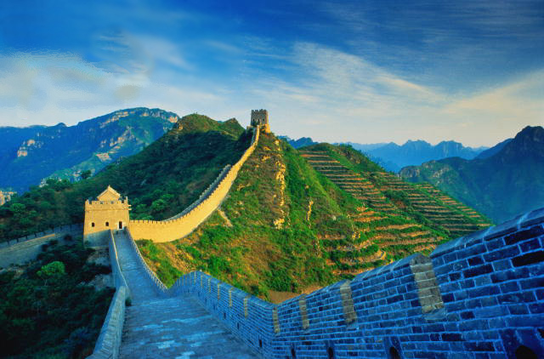The Great Wall of China is a wall that is 10,000 km long and 6-9m in height. This huge wall is on the Inner Mongolia border. This wall was built in the Qin Dynasty or the 7th century BC. It was meant to do keep out the Mongolian Huns. The emperor was afraid they would come and hurt his people so he hoped the Great Wall would keep them out but they came any way and saw the wall as a test of their strength.

If you haven’t seen the Great Wall when you go to China you haven’t seen China at all.

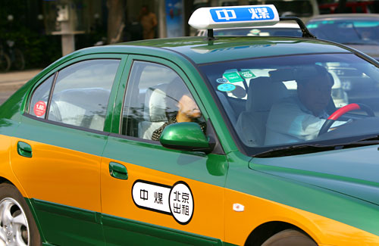**Getting Around**

Transport to and from the airport will be that you take the Airport Express to the nearest station and then you will get a taxi.

For most of the activities it will be a mixture of walking, using the subway and getting a taxi.

To the Great Wall of China you will have a private tour (meaning a private car).

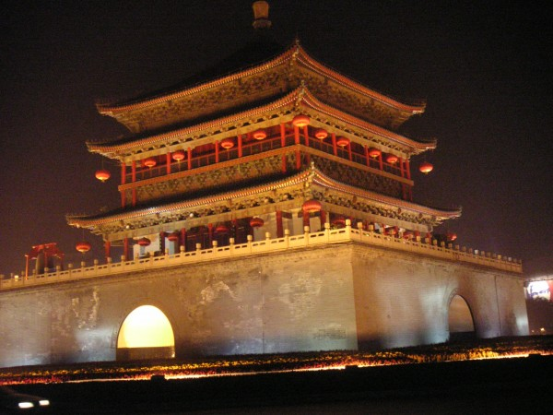[**Xi’an**](http://en.wikipedia.org/wiki/Xian)

[**Weather**](http://www.chinaweatherguide.com/xi'an-weather.htm)

|  |  |  |
| --- | --- | --- |
| **Month** | **High** | **Low** |
| June | 41 | 10 |
| July | 40 | 15 |

**Accommodation**

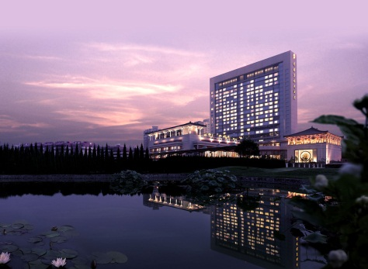Xian might be a very interesting city but it has nice hotels too. One I looked at is the Shangri-La Hotel and it is a lovely hotel that is about 40-45 minutes’ drive to the entrance of the terracotta warriors. It has a lovely view of Xian and is one of the upmarket hotels in Xian.

**Activities**

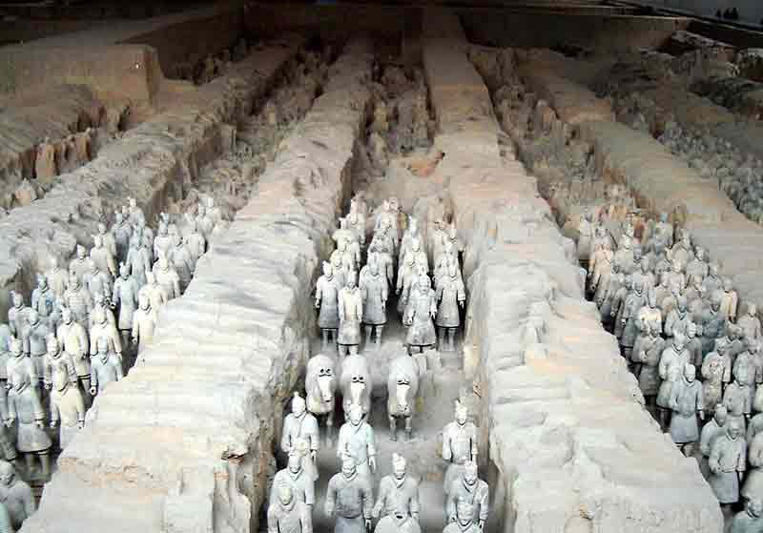**Terracotta Warriors**

The Terracotta Warriors are an army of stone soldiers built in the Qin Dynasty. The emperor wanted them built so when he died he would be safe from any harm. The Terracotta Warriors are an amazing piece of history in China that is why you are going there.

For the Terracotta Warriors you will have a private tour.

**Wandering around the city**

The second day will be spent going around the city and experiencing the local culture. Some places you might go to are: Some Local music and Dance shows, the city wall, the Bell and Drum towers, the Big Goose Pagoda and the Forest of Stone Steles.

**Getting Around**

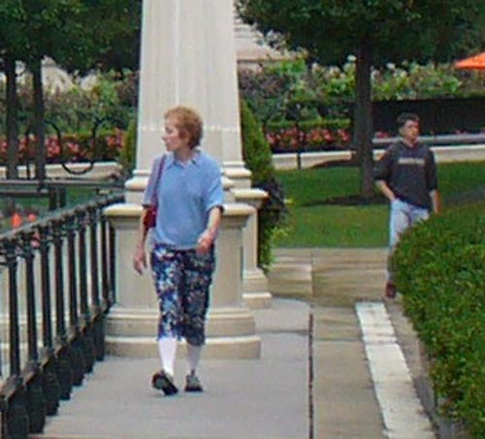Transport to and from the airport will either be a taxi or arrange for a private car to meet you (arranged in Australia beforehand).

To the Terracotta Warriors you will have a private tour (meaning a private car).

On other days you will be walking around Xi’an.

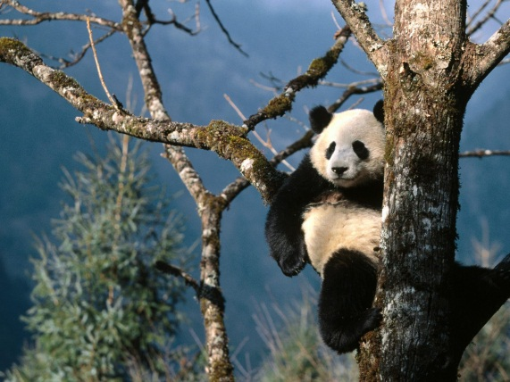[**Chengdu**](http://en.wikipedia.org/wiki/Chengdu)

[**Weather**](http://www.itourbeijing.com/china-weather/chengdu-climate.htm)

|  |  |  |
| --- | --- | --- |
| **Month** | **High** | **Low** |
| June | 26-29 | 19-21 |
| July | 29-31 | 20-23 |

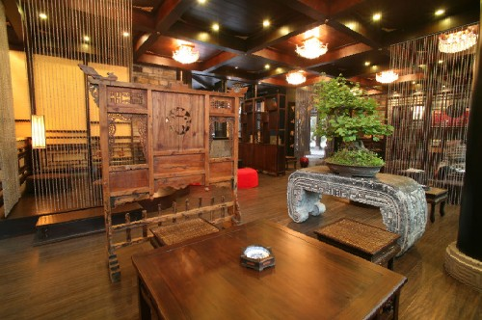[**Accommodation**](http://www.buddhazenhotel.com/en/into.html)

In Chengdu there are the standard hotels, Hilton, Shangri-La but in Chengdu I have found the BuddhaZen Hotel which is a more local and traditional almost like a Chinese peaceful house. It is located in the centre of Chengdu and is 20-30 minutes to the Panda Research Base.



**Activities**

[**Panda Breeding and Research Centre**](http://www.panda.org.cn/english/index.htm)

The Panda Breeding and Research Centre is a lovely place just 10 kilometres /35-40 minutes out of town. It breeds and helps pandas and is a place where the panda’s aren’t in cages and just wander round. You can see them roaming around in the wild and is said to be a wonderful experience.

**Around the city**

The other day will be spent getting into the local atmosphere and wandering around the area. Some places that are interesting might be: the Wu Hou Temple, Jinli Old Street, Du Fu Thatched Cottage and the Qingcheng Mountain.

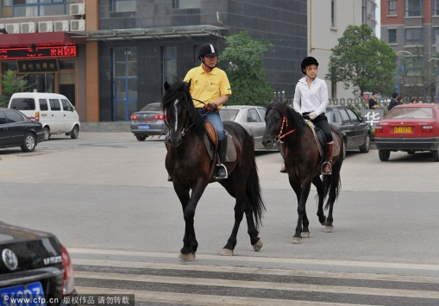**Getting Around**

Transport to and from the airport will either be a taxi or arrange for a private car to meet you (arranged in Australia beforehand).

To the Panda Breeding and Research Centre you will have a private car.

On other days you will be walking around Chengdu.

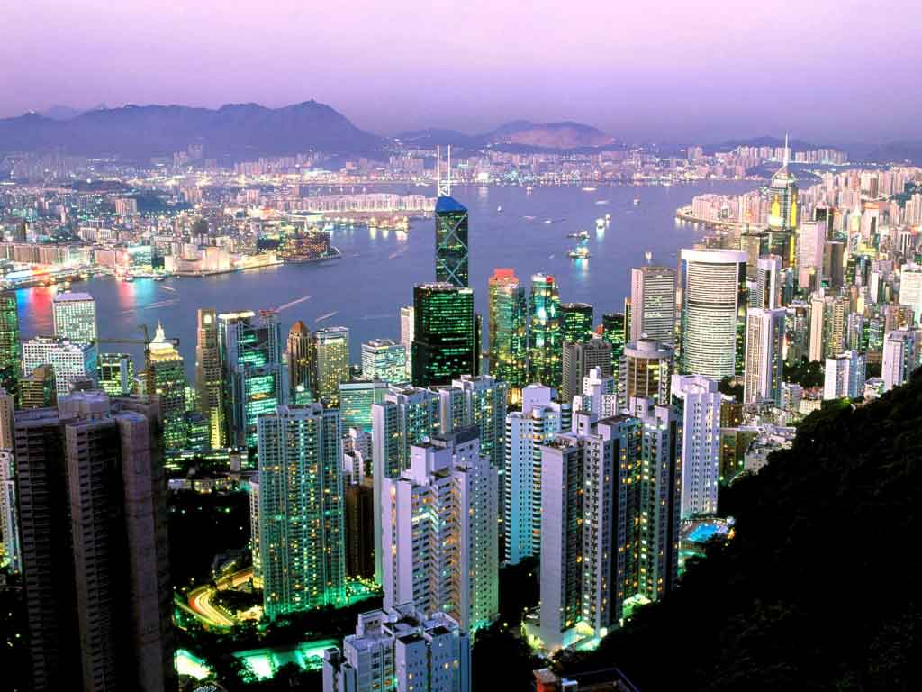[**Hong Kong**](http://en.wikipedia.org/wiki/Hong_kong)

[**Weather**](http://www.chinahighlights.com/hong-kong/weather.htm)

|  |  |  |
| --- | --- | --- |
| **Month** | **High** | **Low** |
| June | 32 | 33 |
| July | 22 | 23 |

[**Accommodation**](http://www.vtc.edu.hk/thotel/)

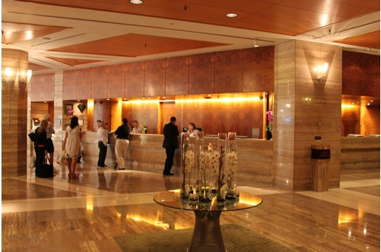Hong Kong is one of the amazing places in the world which is famous for making most of its hotels glamorous. One of my personal favourite chain of hotels, Mandarin Oriental has three hotels in Hong Kong one I thought looked the best is called Mandarin Oriental. It is located on the side of Hong Kong Island that is looking at Kowloon (the other shoreline) and has a stunning look of the water/shoreline. It may be expensive (meaning $530-$750 a night) but it is fully worth it. Another hotel that is more reasonably priced but is still lovely is the T hotel. This hotel is a training hotel (meaning there are lots of young waiters around serving you) yet is still meant to be around four stars. It is located on the side of Hong Kong Island that is facing out to sea and has a lovely view of the ocean. This hotel is priced around $115-$275 a night.

**Activities**

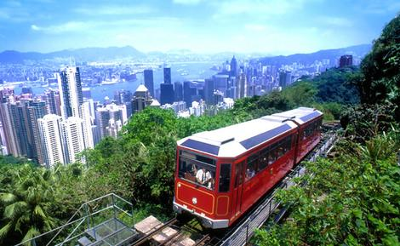[**Victoria Peak**](http://www.thepeak.com.hk/en/)

Victoria Peak is a big peak on Hong Kong Island. At the top it has glorious views of the whole city and much further. You get a tram to the top of the peak that tells you lots about Hong Kong on the way up. You’ll get a taxi to the bottom of the peak.

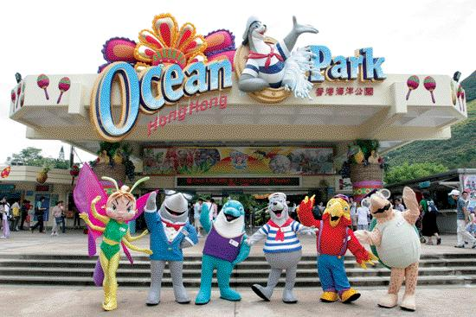[**Ocean Park**](http://www.oceanpark.com.hk/html/en/home/)

Ocean Park is an amazing fun park that is in equal first with Disneyland it has lots of information scrambled in with rides and everything. You’ll get a taxi to Ocean Park.

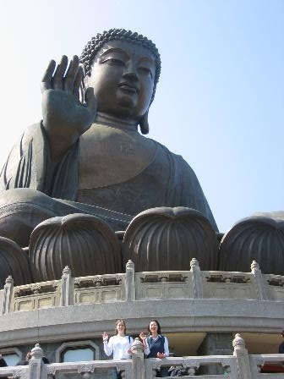**Lantau Island/ Giant Buddha**

On Lantau Island there is a giant Buddha. You climb around 200 steps to get to the top were the Buddha is seated. It is an amazing experience that will truly blow your mind.

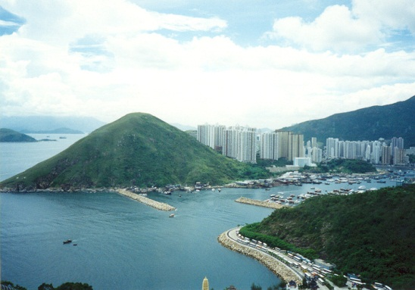**Stanley Markets and Aberdeen**

The Stanley Markets and Aberdeen are amazing parts of Hong Kong. Aberdeen is a busy harbour that has lots of things happening everywhere. A fantastic part of Hong Kong you need to see. The Stanley Markets are Chinese markets that sell everything from shoes to flowers to food everything you can find there. They are a place you need to go to, to experience true Chinese culture.

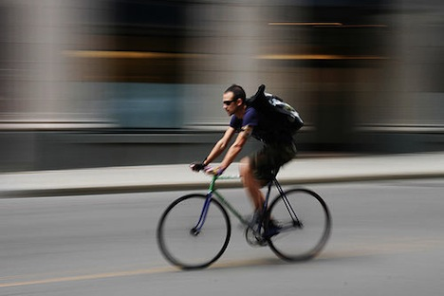**Getting Around**

Transport to and from the airport will be that you take the MTR Airport Express to the nearest station and then get a taxi to your hotel.

To Victoria Peak use the peak tram to get the top.

Take the Star Ferry from Hong Kong Island to Kowloon.

For most of the activities it will be a mixture of walking, using the subway, using the bus and getting a taxi.

**Bibliography**

*Allianz*. [online]. (2012).

<http://www.allianz.com.au/travel-insurance [Accessed 17/5/12]>

*Beijing! Travel Tips*. [online]. (2006). <http://www.beijingtraveltips.com/tips/money_1/currency.htm> [Accessed 22/5/12]

*Buddhazenhotel*. [online]. (2012). <http://www.buddhazenhotel.com/en/into.html> [Accessed 18/5/12]

*CDC*. [online]. (2012). <http://www.cdc.gov/travel/destinations/china.htm> [Accessed 17/5/12]

*China Itinerary*. [online]. (2012). <http://www.chinaitinerary.com/> [Accessed 10/5/12]

*China Travel Service*. [online]. (2012). <http://www.chinatravel.com.au/about/faq> [Accessed 17/5/12]

*Expert Flyer*. [online]. (2012). <http://www.expertflyer.com> [Accessed 19/5/12, 30/5/12]

*Google Maps*. [online]. (2012). <http://maps.google.com.au/maps?hl=en&tab=wl> [Accessed 10/5/12]

*Hong Kong International Airport*. [online]. (2012). [http://www.hongkongairport.com/eng/transport/to-from-airport/airport-express.html](http://www.hongkongairport.com/eng/transport/to-from-airport/airport-express.html%2028.5.12) [Accessed 28/5/12]

Hughes, H. (2006). *500 Places to take Your Kids Before They Grow Up*, Frommer’s, Hoboken, New Jersey.

*Lonely Planet.* [online]. (2012). <http://www.lonelyplanet.com> [Accessed 21/5/12]

*Lonely Planet.* [online]. (2012). <http://www.lonelyplanet.com/china/practical-information/travel-insurance> [Accessed 22/5/12]

*Lonely Planet.* [online]. (2012). <http://www.lonelyplanet.com/china/practical-information/money-costs#2> [Accessed 22/5/12]

*Qantas.* [online]. (2012). <http://www.qantas.com.au/travel/airlines/home/au> [Accessed 19/5/12, 30/5/12]

*Shangrila Hotels and Resorts.* [online]. (2012). <http://www.shangri-la.com/xian/> [Accessed 28/5/12]

*Shanghai Metro* [online]. (2012). <http://www.shmetro.com/node155/node159/201004/con103744.htm> [Accessed 17/5/12]

Storey, R. (1994). *Beijing – City Guide*, Lonely Planet, Hawthorn Victoria.

Storey, R. and Goncharoff, N. and others. (1998). *China*. Lonely Planet, Hawthorn Victoria.

*Tour Beijing.* [online]. (2012). <http://www.tour-beijing.com/xian_travel_guide/top_10_things_to_do_in_xian/> [Accessed 17/5/12]

*Tour Beijing.* [online]. (2012). [http://www.tour-beijing.com/blog/china-travel/china-top-10/top-10-chengdu-attractions-top-10-things-to-do-in-chengdu/](http://www.tour-beijing.com/blog/china-travel/china-top-10/top-10-chengdu-attractions-top-10-things-to-do-in-chengdu/%20%20) [Accessed 17/5/12]

*Travel Doctor.* [online]. (2010). <http://www.tmvc.com.au/> [Accessed 17/5/12]

*TripAdvisor.* [online]. (2012). <http://www.tripadvisor.com.au> [Accessed 24/5/12]

*Tripline* [online]. (2012). <http://www.tripline.net> [Accessed 29/5/12]

*Wendy Wu Tours.* [online]. (2012). <http://www.wendywutours.com.au/china-holiday-tours> <http://www.chinaitinerary.com/> [Accessed 10/5/12]

*Wikipedia.* [online]. (2012). <http://en.wikipedia.org> [Accessed 10/5/12, 17/5/12, 19/5/12, 21/5/12, 28/5/1230/5/12]

*Wikipedia.* [online]. (2012). <http://en.wikipedia.org/wiki/Xi'an> [Accessed 10/5/12]

*Wikitravel.* [online]. (2012). <http://wikitravel.org/en/Xi'an> [Accessed 10/5/12]

*World First Foreign Exchange.* [online]. (2012). <http://www.worldfirst.com.au/?ID=1078&gclid=CKim-PfyhbACFU1spAod0CFxjQ> [Accessed 17/5/12]

*WWF Global.* [online]. (2012). <http://www.panda.org.cn> [Accessed 13/5/12]

***Other websites accessed***

<http://www.chinahighlights.com/hong-kong/weather.htm> , <http://www.itourbeijing.com/china-weather/chengdu-climate.htm> , <http://www.chinaweatherguide.com/xi'an-weather.htm> , <http://www.chinahighlights.com/beijing/weather.htm> , <http://www.tour-beijing.com/shanghai_tours/shanghai_climate.php> 22.5.12

<http://en.wikipedia.org/wiki/Yuan> , <http://en.wikipedia.org/wiki/Chinese_currency> 22.5.12

<http://en.wikipedia.org/wiki/Shanghai>, 10.5.12<http://wikitravel.org/en/Shanghai/Old_City> 17.5.12, <http://www.fourseasons.com/shanghai/>, <http://en.wikipedia.org/wiki/Maglev> 28.5.12

<http://www.hotel37.com/EN/index.asp>, <http://www.travelchinaguide.com/cityguides/beijing/transportation/airport-express-train.htm> , <http://en.wikipedia.org/wiki/Airport_Express,_Beijing_Subway> 28.5.12