Makes
20

Ingredients
- 1/2 cup plain flour
- 2 tablespoons cornflour
- 1/4 cup water
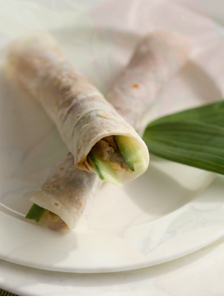
- 1/4 cup milk
- 2 eggs
- 2 tablespoons butter, melted
- 1 Peking duck, from Asian food store
- 1 Cucumber
- 6 green onions, washed
- 1/2 cup hoisin sauce
Or
- Bought pancakes from Asian food store
- 1 Peking duck
- 1 Cucumber
- 6 green onions, washed
- 1/2 cup hoisin sauce

Method
- Into a food processor put flour, cornflour, water, milk, eggs and half the butter. Combine until smooth. Pour into a jug, then cover and leave for 15 minutes.

- Melt the rest of the butter in a container in the micro wave for 30 seconds on high. Heat a non-stick frying pan over medium heat. Each time putting a new pancake in, brush a layer of the butter on the pan.

- Pour a large spoonful of the mix into the pan, then spread to make a pancake. On the first side cook for about 2 minutes then turn it over and cook for another 1 minute. Move to plate and keep repeating until the batter has finished.

- Heat a non-stick frying pan over medium heat. Brush with remaining butter. Pour a tablespoonful of batter into frying pan. Spread to form a thin pancake, about 16cm in diameter. Cook for 2 minutes. Turn and cook for a further 1 minute. Transfer to a plate. Repeat with remaining batter.

- Take off the meat and skin from the already cooked duck and shred. Cut your cucumber and shallots (otherwise known as spring onions) just so they can fit in the pancakes around 10 cm.

- Put dollop of hoisin sauce on the pancake and spread it out. Place some duck meat and skin on the pancake, then a piece of cucumber and shallot at the bottom and roll.
Tip: The duck pancakes are better severed warm so try severing them straight away, but if you can’t or you used bought pancakes put them in the microwave for a minute on medium.
Other Chinese recipes

