Women in Rural China
Every day women in rural China work for up to 15 hours. This is work done both in the fields and in the home. The type of work they perform changes with their age. For example women over the age of 50 spend more time doing housework, as work in the fields is too hard for them. Middle aged women spend roughly half their time in the field and half at home. Younger women prefer to do work other than farming.
Traditional Chinese culture does not treat women equally. Traditional Chinese men tend to like women to be feminine and can feel threatened by tougher and smarter women. Traditionally men are less worried about how a lady looks, but is more concerned if she can cook and have his children, in particular a son.
Women are generally are taught to be quiet and careful. Some men like their wife’s because they never ask for anything.
In traditional China, the farm was passed down from the father to his son. If he had no son he would give it to a close male relative. The man would never give it to his daughter.
Rural women normally get married at around the age 18. They are expected to care for the sick, the young and the old but also have to work on the fields. They work nonstop and do not get rewarded for this. They are considered to be the property of men (fathers, sons and husbands).
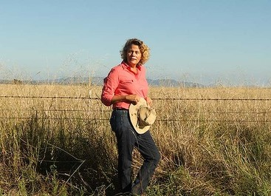
Women in Australian rural life are farmers, cooks and sometimes mothers, also women work as crop growers meaning if they live on a farm on their own they grow their own crops and sometimes if the local grocer is 2 hours away they grow their own crops.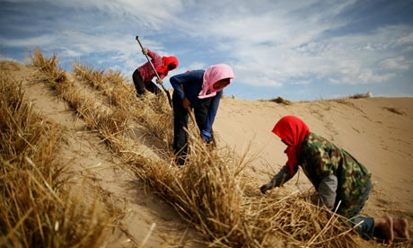
Women in rural China are the same as men they work day and night cutting, planting, digging crops and cook for the men and themselves.

